1.Abstract Sheikh

Introduction

Motivation  
Smart farming  
Goals  
paper flow

Background (fundamental and related works)

Deep learning  
 model  
 training

2.Design Abis

Diagrams

Requirements (system)   
 Use case (component) *  
 Activity diagrams (component)*  
 Sequences(component)  
 Architecture  
3.Verification (Zaff)

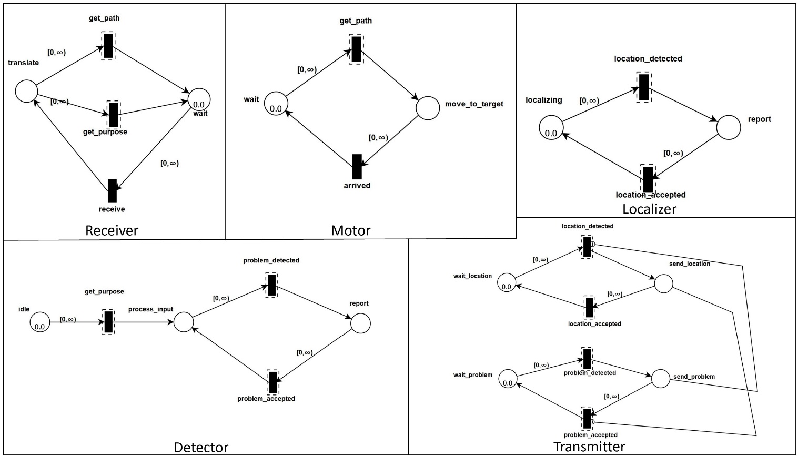

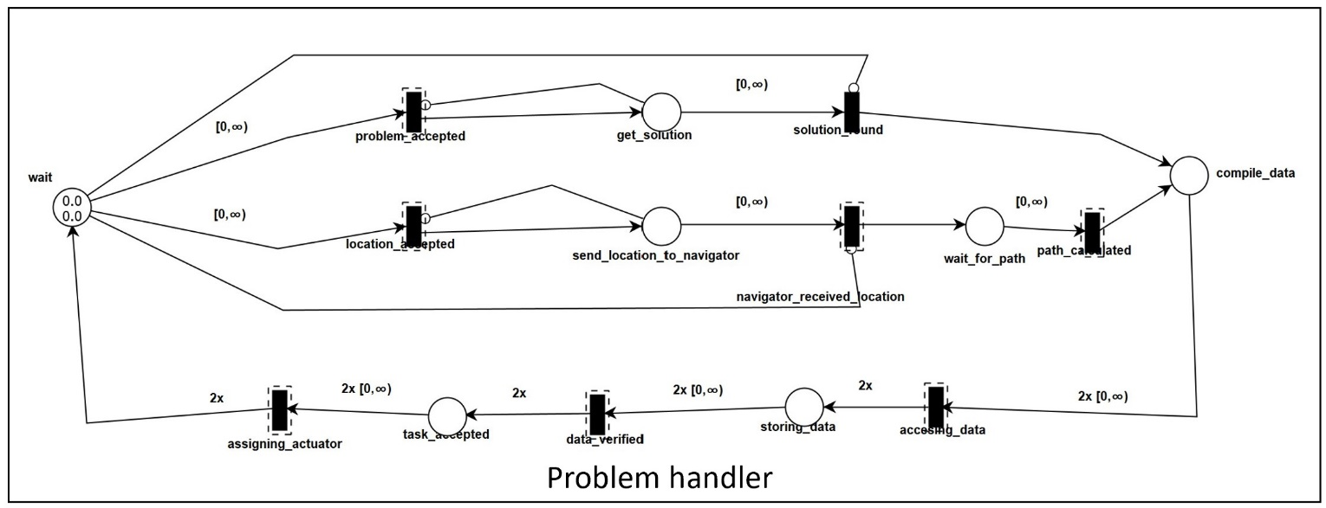

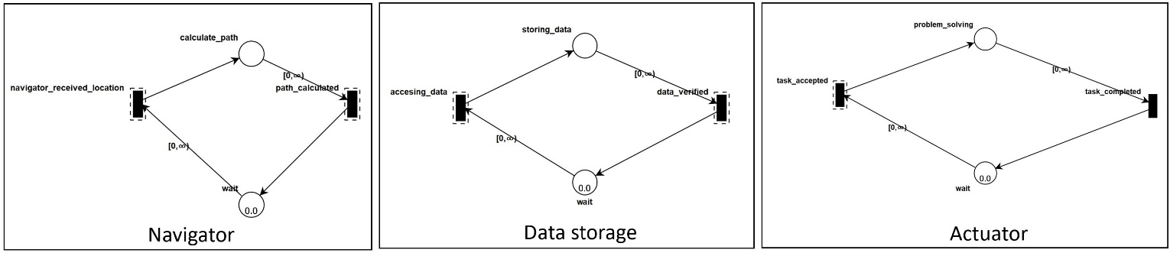

After all model diagrams has been made, we now must verify our model. Model verification is a methodology for developing computational models. This model can be used to make engineering predictions with quantifiable confidence. Model verification and validation are extremely important in today's industry. This model has influenced many aspects, including time consumption, cost, and many others. Verification and Validation of Simulation Models are performed using a variety of techniques. In this case, TAPAAL simulation is being used to validate our Precision farming system. Based on fig))))), we converted all the diagrams to the TAPAAL model. Before delving deeper into the flow of our Precision farming system, some key information about the TAPAAL model is provided. The circles are called places, and the rectangles are called transitions. They are linked together by either standard arcs between places and transitions or transport arcs. Tokens govern the net's behavior. Each location can hold a certain number of tokens, and each token has its own real-time age.

The concept of our model is divided into two major parts, detecting problems such as disease on plants and weeds and detecting the location of the drone. The drone is divided into 5 small components which are Receiver, Motor, Detector, Localizer and Transmitter as shown in fig)))))). It should be noted that this scenario takes place in the middle of the day and not when the system is idle. Consider how the drone detects a problem on a field. de Wait place which is located at Receiver component will fire in the to receive transition with one token. The translate place will then fire the token get path and get purpose transitions. Motor's component shares the get path transition. The token will fire to move to target location. Meanwhile, the get purpose transition is shared with the component of Detector. If the Detector detects a problem on the field, problem detected transition will fire the token report place. In other words, the Detector will report the problem to the transmitter, who will then send the data to the Problem handler. According to figPH)))))), the first place is a wait place, which consists of two tokens. Tokens must be fired separately to the problem accepted and location accepted transitions. As a result, after the Problem handler accepts the problem, it must wait for the Localizer component to send the coordinates to the Transmitter. The data will then be sent to the Problem handler by the Transmitter. After both tokens are fired into their respective transitions, it is important to the Problem handler to find a suitable solution and send the coordinate to the Navigator. When the Navigator receive the location, it will fire a token to calculate path place. Given that they have a shared transition, the calculated_path transition is returned to the Problem handler. Both tokens from solution found transition and path calculated transition will fire to compile data place. This time, the total number of tokens will be two. Compile data will then fire both tokens to the accessing data transition, which is shared with the Data storage component. The token will be fired to storing data place during the accessing data transition. Furthermore, the Problem handler will verify the data and fire the token to the assigning_actuator transition. The Actuator will solve the problem using the discovered solutions and calculated path given from Problem handler. In the Actuator component, when the problem is resolved, the token is sent to the task_completed transition as proof that the actuator has taken care of the issue. Finally, both tokens will return to the wait state until the drone detects a new upcoming problem.

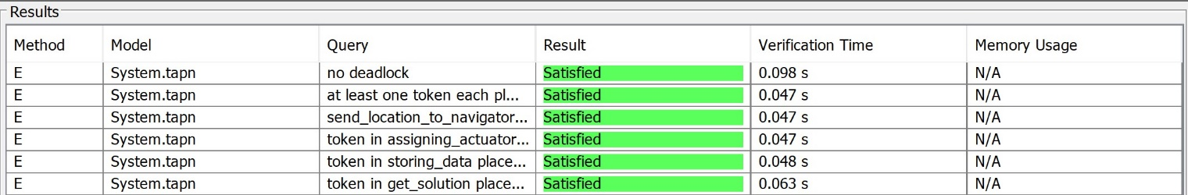

After modeling our Precision farming system with TAPAAL, we ran a few queries to ensure and verify the correctness of ur system. First, we determine whether the deadlock is likely to occur during all processes. As shown in fig)))))) there is no deadlock, and the result is satisfied. The number of tokens in the Navigator component is also checked, with at least one token in each place. Next, the send location to navigator and wait for path places are checked and verified to ensure that no token is present at the same time. Furthermore, during program execution, the token in the Actuator component, assigning_actuator place and the Data storage component, storing_data place must not be equal to 1 or greater than 2. The outcome is also satisfactory.

4.Implementation ammar

Dataset

Data preprocessing

models

Training

Comparisons: Analysis of results

5.Evaluation (Simulation) Kimi

\section{Evaluation}

This chapter describes how the results achieved during the simulation. First, we explained how field of combination sugar beets and weeds was created. Then, we assigned the drone to perform tasks in the field. Lastly, all the data that has been collected by the drone will be compared and to be evaluated.

Field

\subsection{Field}

To simulate this project, we first generated a sugar beet and weed field. The field will later be used by a drone to detect and classify crops. This field was made using a 30x30 images array, and the images data is places randomly in the array. In total, we will have 899 images of random class of plants in the field.

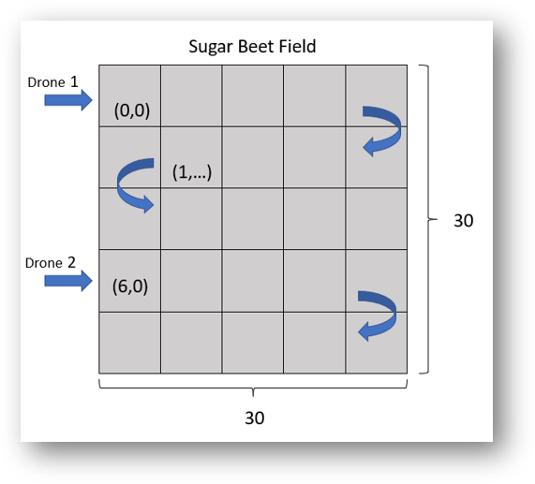

Drone  
 \subsection{Drone}

After we have created the field, we continue by assigning the drones that can move around in the field as mention above. The main task of these drones is to read the images and detect weed or sugar beets in the field. As our field is 30x30 array we have assigned 5 different drones to move in 6 rows respectively. The movement of each drone is going to be like snake pattern, which is left to right and going down, and continue from right to left so on and so forth. After the drones have finished moving in the field, the collecting data will be compiled in master list.

Analysis of results

\subsection{Analysis of results}

In order to compare how the models performed, comparisons were made between the accuracy of the models. Table below shows the result of each trained models. Same as in training phase we compared between ResNet18, ResNet34, ResNet50, AlexNet, Vgg19, SquezeNet and DenseNet201 during the evaluation. In training phase, we figured out that DenseNet201 has the best accuracy. Yet, during the real simulation we found out that Vgg19 has the best actual accuracy with 97.44% while DenseNet201 with 93.88%. The results were calculated by comparing the considered weed or sugar beets with the original weed or sugar beets crop in the field.

\begin{table}

\centering

\begin{tabular}{|c|c|c|c|c|}

\hline

Model & Training Accuracy & Original Data (Weed/SugarBeets) & Result (Weed/SugarBeets) & Actual Accuracy \\

\hline

ResNet18 & 77.652\% & 449/450 & 442/172 & 80.088\% \\

\hline

ResNet34 & 85.855\% & 449/450 & 442/251 & 71.301\% \\

\hline

ResNet50 & 87.407\% & 446/453 & 444/70 & 91.888\% \\

\hline

AlexNet & 73.826\% & 449/450 & 437/151 & 81.777\% \\

\hline

Vgg19 & 86.444\% & 449/450 & 443/25 & 97.442\% \\

\hline

SqueezeNet & 79.859\% & 449/450 & 444/215 & 75.528\% \\

\hline

DenseNet201 & 90.387\% & 449/450 & 447/52 & 93.888\% \\

\hline

\end{tabular}

\end{table}

Conclusion

Project managements

Affidavit

\chapter*{Affidavit}

I Muhammad Amirul Hakimi bin Zaprunnizam herewith declare that I have composed the present paper and work by myself and without use of any other than the cited sources and aids. Sentences or parts of sentences quoted literally are marked as such; other references with regard to the statement and scope are indicated by full details of the publications concerned. The paper and work in the same or similar form has not been submitted to any examination body and has not been published. This paper was not yet, even in part, used in another examination or as a course performance.

. ~\\

Lippstadt, \today\\[.6cm] %<city>, <date>

Muhammad Amirul Hakimi bin Zaprunnizam\\ % signature

\rule[0.5em]{20em}{0.5pt}

Acknowledgment

References

Appendix